**IREVOLUTION : A DATA DRIVEN EXPLORATION OF APPLE’S IPHONE IMPACT IN INDIA**

**1. Introduction**

**1.1. Overview**

Analyzing data on Apple's market share in India can show its penetration and impact on the smartphone market.Evaluate the economic impact through data on iPhone sales, revenue generated, and employment opportunities created directly and indirectly.Analyzing data on Apple's market share in India can show its penetration and impact on the smartphone market.Evaluate the economic impact through data on iPhone sales, revenue generated, and employment opportunities created directly and indirectly.

**1.2. Purpose**

To better understand consumer behavior and preferences, and how these factors have been affected by the availability of iPhones.To determine the impact of iPhones on education and skill development, especially in urban and rural areas.

**2. Problem Statement & Design thinking**

**2.1. Empathy Map**

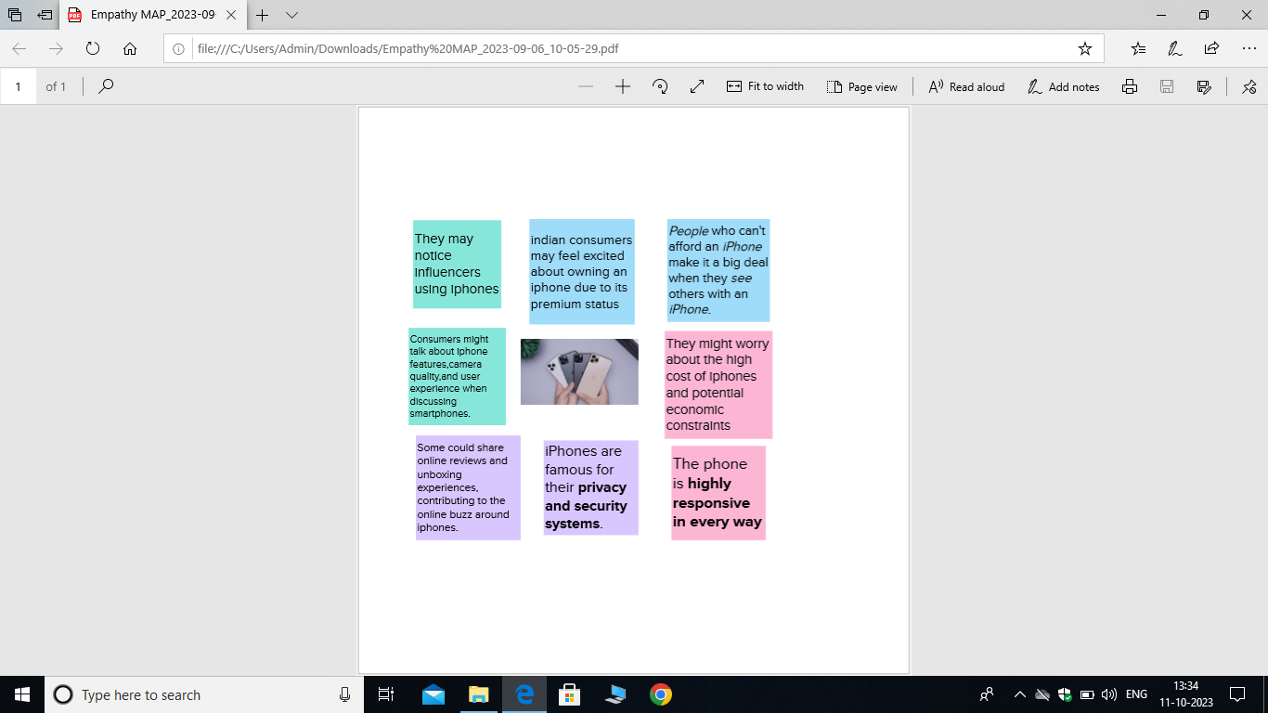

**2.2. Ideation and Brainstorming Map**

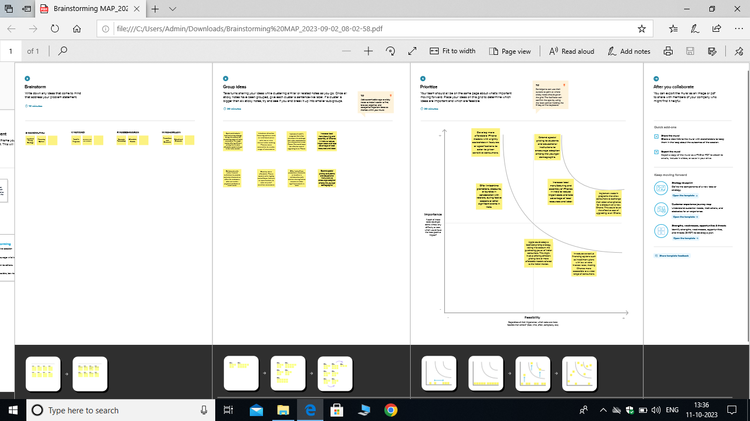

**3. Result**

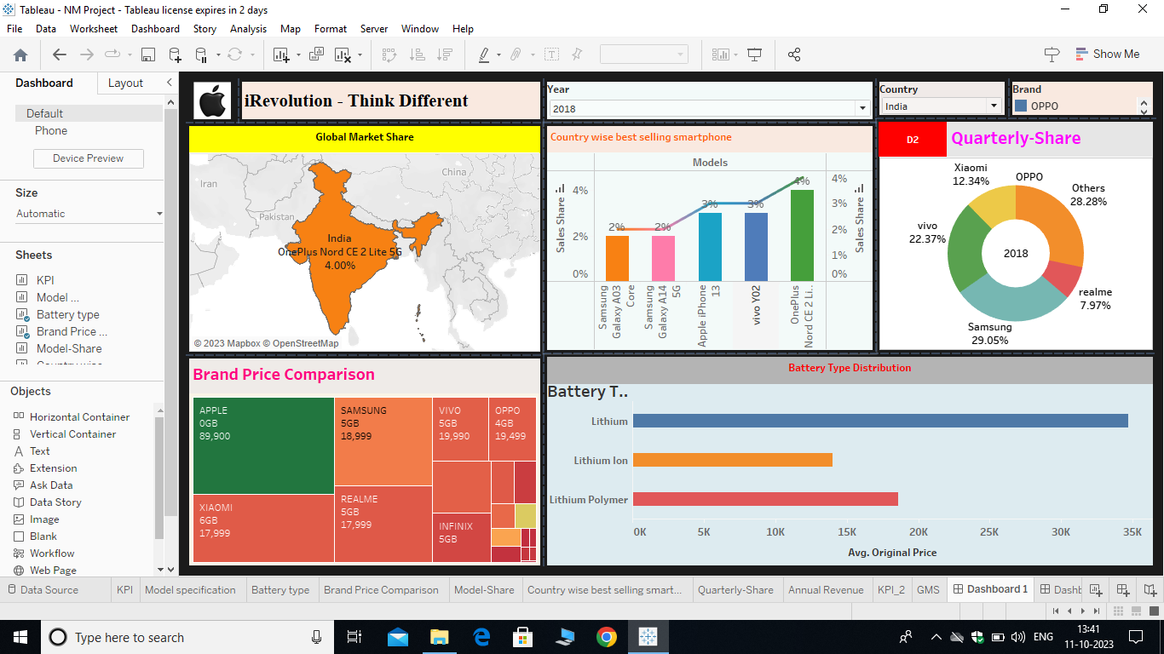

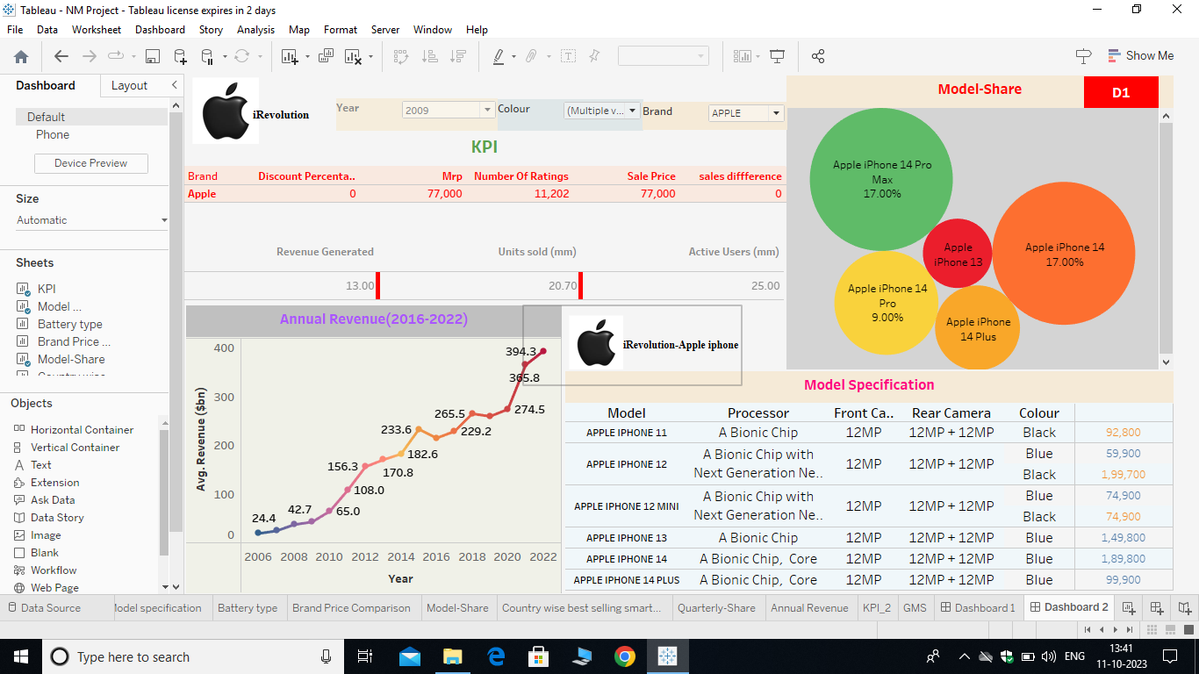

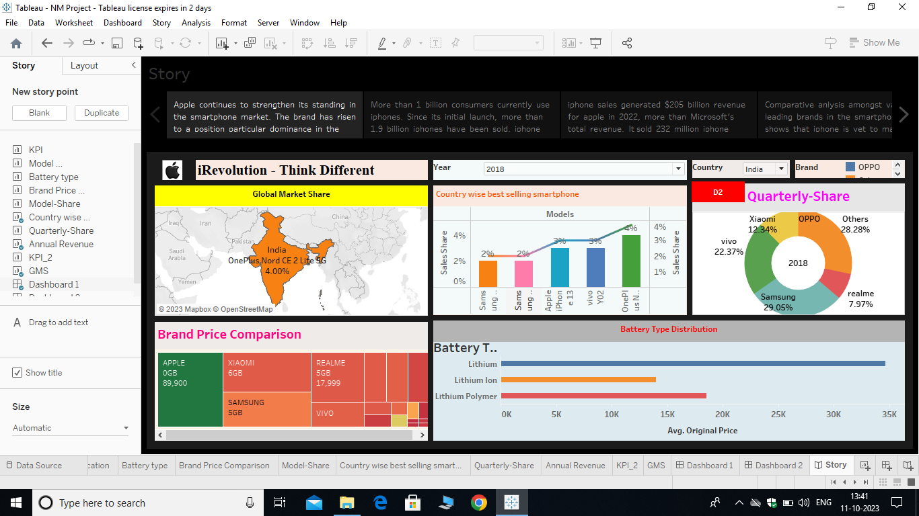

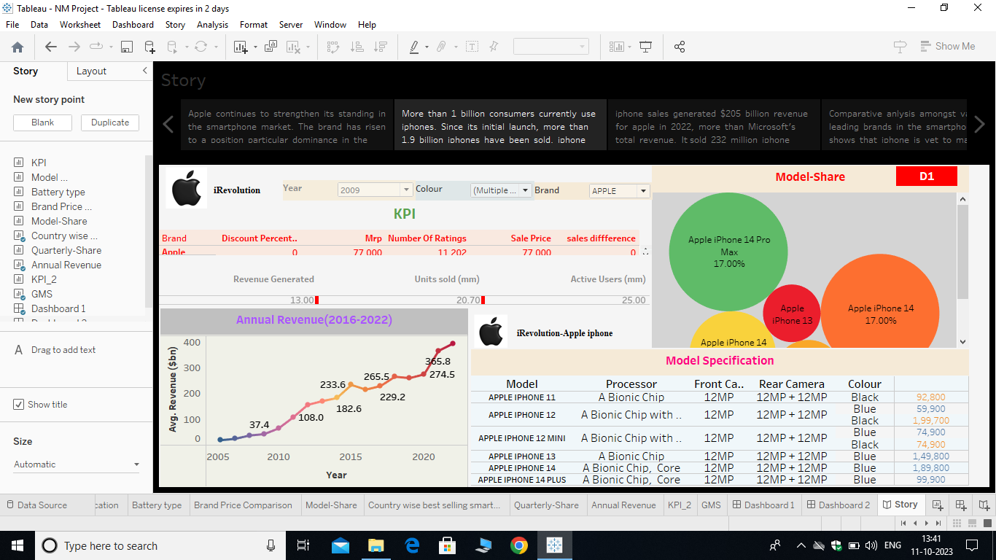

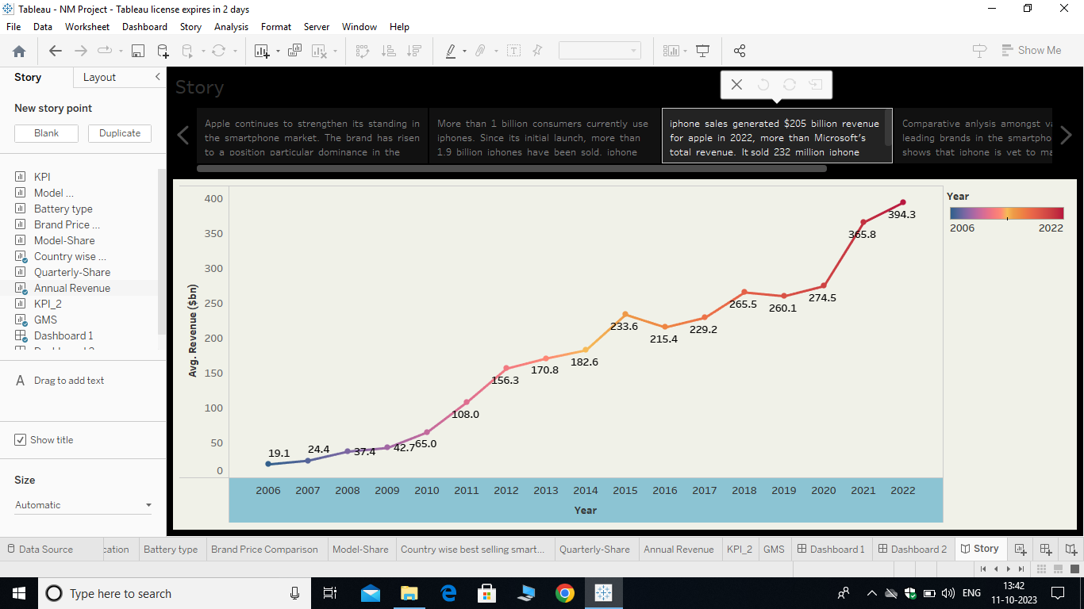

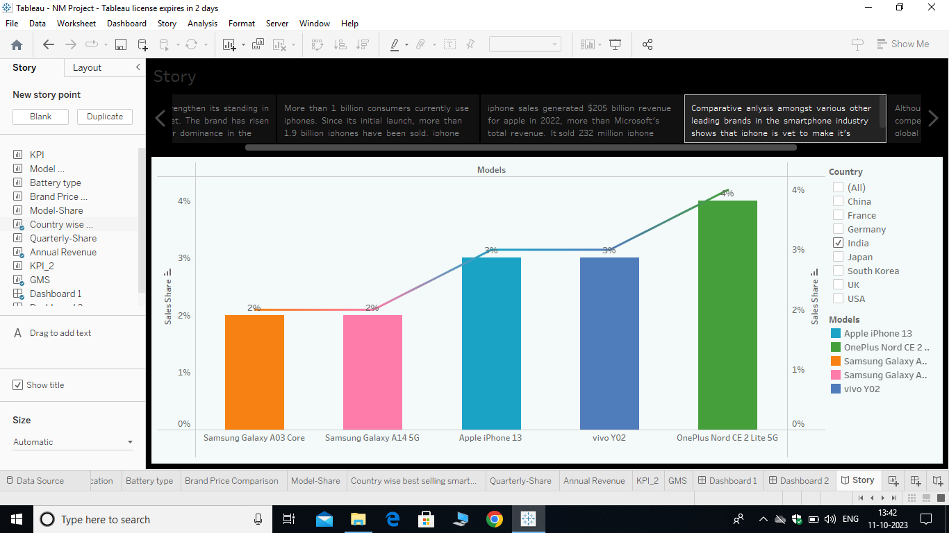

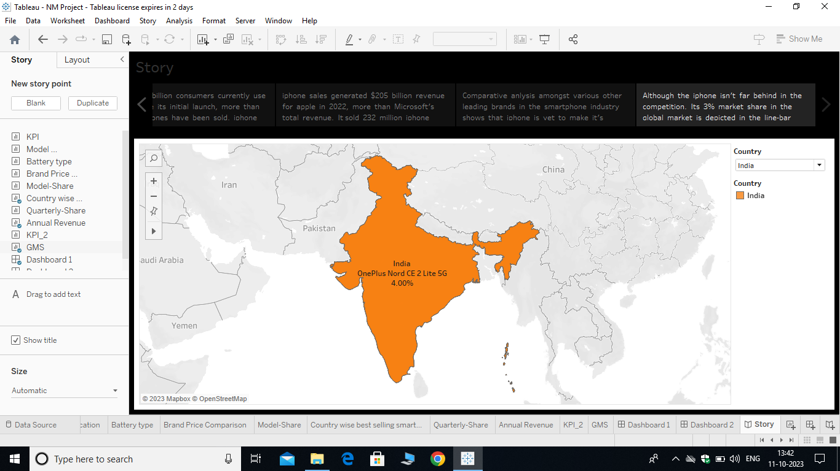

**4. Advantages & Disadvantages**

**Advantages**

**Improved Product Development:**

Consumer preferences and app ecosystem insights can guide product development and feature enhancements.

**Educational Enhancement:**

Understanding how iPhones impact education can lead to initiatives for skill development and digital literacy.

**Disadvantages**

**Limited Historical Data:**

Depending on the specific metrics being examined, there may be limited historical data available for analysis, particularly for newer trends or technologies.

**Data Accuracy and Reliability:**

Data sources may not always be accurate or reliable, leading to potential errors or biases in the analysis.

**5. Applications**

**Business Strategy Development:**

Companies operating in the smartphone industry can use this data to refine their strategies, pricing models, and product offerings in the Indian market.

**Investment Decisions:**

Investors can assess the potential for growth in the smartphone market and make data-driven investment decisions in companies related to this industry.

**6. Conclusion**

a data-driven exploration of Apple iPhone's impact in India demonstrates the multifaceted role that these devices play in the country's socioeconomic and technological landscape. The findings can be used by businesses, policymakers, investors, and consumers to make informed decisions, adapt strategies, and contribute to the continued growth and development of the Indian tech market.

**7. Future Scope**

**Advanced Data Analytics:**

Future explorations can benefit from more advanced data analytics techniques, including machine learning and AI, to uncover nuanced insights from large and complex datasets.

**5G and Connectivity Impact:**

With the rollout of 5G technology in India, research can focus on how this advanced connectivity impacts iPhone usage, network infrastructure, and the development of new applications and services.

**Sustainability and E-Waste:**

Examine Apple's efforts in sustainability, recycling, and e-waste management in India, as environmental concerns gain prominence.